Volume 24 http://acousticalsociety.org/
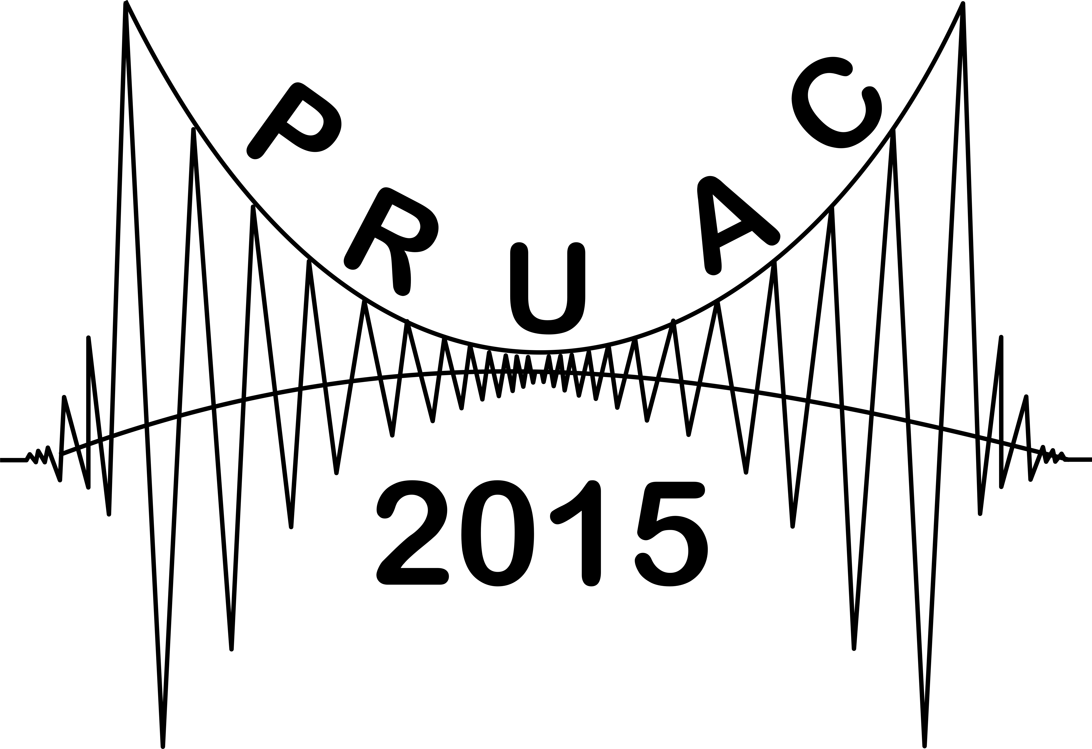
5th Pacific Rim Underwater Acoustics Conference
Vladivostok, Russia
23-26 September 2015

{Title} [Capitalize only first word: And after colon]
{First X. Author and Second X. Author – from a U.S. university or laboratory}
{Department, Affiliation, City, Abbrev. State; email1, email2} [Use styles to define additional authors and affiliations or copy and paste. Delete authors as needed.]
{Third A. Author – from a U.S. company, no department}
{Affiliation, City, ST; email3}
{Fourth B. Author – International affiliation}
{Department, Affiliation, City, Province, Country; email4}
{Fifth A. Author and Sixth B. Author – International affiliation, no department}
{Affiliation, City, Province, Country; email5, email6}
{Insert 200 word max abstract here. It need not be identical to the meeting abstract, and should contain principal results and conclusions. Cover page author information must match submitted author metadata to avoid delays in manuscript processing. All the spaces between different sections of the cover page have been predefined using text styles and hard-coded extra spaces between lines should not be used. Do not include any acknowledgments in the abstract, but rather include them in the POMA manuscript. Export this document as a PDF and upload it as part of the submission package. See http://acousticsauthors.org or the POMA MS Word template for further instructions on manuscript preparation.}

